Documentation
https://kb.segger.com/UM08022_Flasher

Flasher ARM Specs
Supports ARM7, ARM9, and Cortex-M.
Flashes through SWD at 170-300 kB/s.
Needs USB power (5V, >100mA)
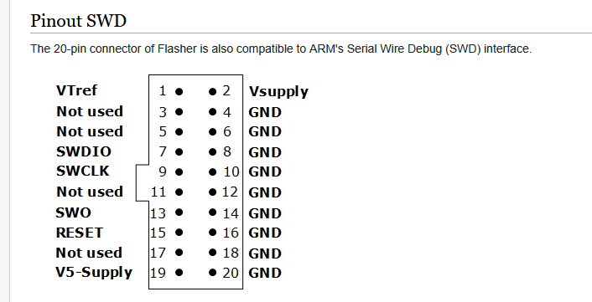

Software Needed
J-Flash: Main programming app
J-Link Commander: CLI for flasher
Flasher Configurator: Configures device/gets debug data (optional, debug only)

Download link for the software pack: https://www.segger.com/downloads/flasher#FlasherSoftwareAndDocumentationPack

Device Use
https://kb.segger.com/Flasher_-_Working_with_Flasher

Setting up Secure Mode:
设置安全模式

- Plug flasher into PC via USB, LED should change from red to solid green when connected
把flasher编程器通过usb线插入到PC，小灯会由红色变成绿色，意味着PC已检测到flasher。
- Open J-Link Commander and run “securearea create” to make an encrypted section (“secure area”) for the files
打开 J-Link Commander 并运行“securearea create”，为文件创建一个加密区域（“安全区域”）

  - 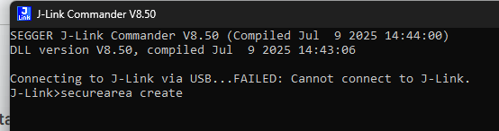
- The flasher is now configured to use the secure area for programming and will do so by default
编程器flasher现已配置为使用安全区域进行编程，
默认情况下将这样做

Using Flasher in Standalone Mode with secure area (single program only):
在standalone mode下使用flasher，并带有安全区域 (仅限单个程序)

- Plug flasher into PC via USB, LED should change from red to solid green when connected
把flasher编程器通过usb线插入到PC，小灯会由红色变成绿色，意味着PC已检测到flasher。

- Open J-Flash and use a project template for whatever MCU we are using
打开J-FLASH软件，并根据所用的MCU型号配置好相关参数。

  - 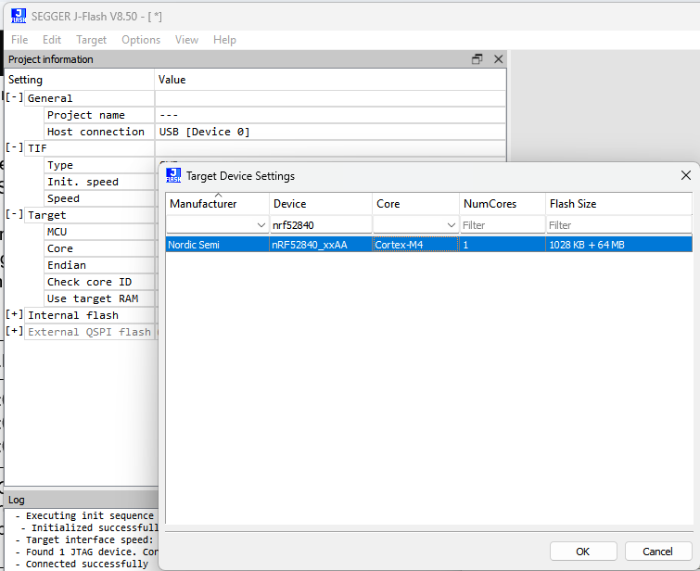
- Load data/hex files for programming (should merge the files with File > Merge Data FIle if needed)
通过菜单File > Open Data File导入hex文件到j-flash里 (已确认 – 是open ，有时会需要Merge Data File但目前不考虑)

  - 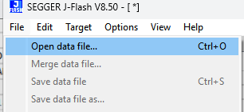
- Create a new .hex file on your computer with the following content depending on the microcontroller being programmed and merge it with the previous hex files:
会在你的电脑里创建一个新的hex文件（不同的mcu会有所不一样），并且跟之前的hex文件合并在一起。（待理解）

Microcontroller series | .hex content | Meaning
NRF528xx | :020000041000EA  :0412080000000000E2  :00000001FF | Store the data 0x00000000 at memory address 0x10001208
STM32C0xxxx | Currently unavailable, readback protection needs to be set through firmware | Store the data 0x000000FF00000000 at memory address 0x1FFF7800

This will set readback protection on the programmed device.
这会对已编程的设备设置读保护。

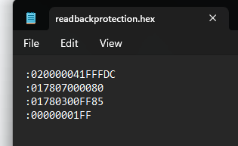
- Go to Options > Project Settings > General and make sure USB is selected. Save and close the window.
菜单options > Project Settings > General，确认已选择usb

- Click File -> Download config & data file to Flasher, and check the log to make sure it was successful
菜单 File -> Download config & data file to Flasher，把配置和hex下载到flasher中，检查log确认显示成功的信息

- Disconnect the flasher from the PC, then hold the PROG button while reconnecting it to enter file access mode (flasher treated like a USB storage device)
Disconnect断开编程器flasher和电脑的连接，长按PROG按钮，将把flasher作为一个u盘连接到电脑

- In the Flasher device, create a file called “Cntdown.txt” and write a single decimal number (<= 4,294,967,295) which will be the number of successful flashes that the device will execute before needing to be reconfigured
在flasher设备中，手工创建一个名为Cntcown.txt文件，并写入一个十进制数如100 (<= 4,294,967,295)，该数表示设备在需要重新配置之前执行的成功闪存次数 (已理解：就是允许烧录多少次)

  - 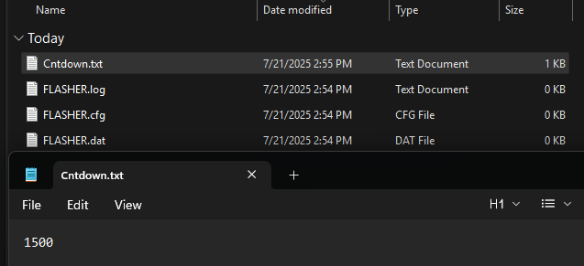
- In the root directory of the flasher, create a folder named “_SECURE” and move all files from root into that folder (except the .log file, if present)
在闪存器的根目录中，创建一个名为“_SECURE”的文件夹，并将根目录中的所有文件移动到该文件夹中（.log 文件除外，如果存在）

  - Note that this will erase anything currently in the secure area
注意，这将删除安全区域中的所有内容 (待理解—实际应该是隐藏)

  - 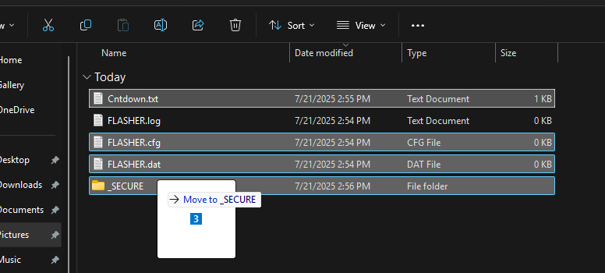
- Disconnect the flasher and reconnect it in normal mode, wait for the LED to turn solid green (it may take a while)
Disconnect编程器flasher，然后在normal mode下重新连接它，等待小灯变成绿灯。（待理解 -- normal mode）

  - Once lit, all files have been moved to an encrypted partition and the “_SECURE” folder will be deleted
一旦点亮，所有文件将被移动到加密分区，“_SECURE”文件夹将被删除

  - The only file in the public area should be the logfile
在public区域，只剩下logfile

- The Flasher now is configured for standalone mode and can be disconnected from the PC and just run off of USB power
编程器Flasher 现在配置为独立模式，可以与 PC 断开连接，只需使用 USB 电源即可运行

- Plug in board to be programmed and press the “PROG” button on the flasher to start programming. The green LED shows what stage it is in:
插入要烧录的板子，然后按PROG按钮开始编程。绿灯按阶段显示如下：
  - 6 Hz blinking = Erasing
  - 2 Hz blinking = Programming
  - 5 Hz blinking = Verifying

- Flash is successful if green LED is solid and red LED is off
如果绿灯长亮，且红灯熄灭，则表示烧录成功

  - Either way, the PROG button can be pressed again to restart the process
不论哪种情况，可再次按下PROG按钮，重新烧录

  - Error messages are available in the FLASHER.LOG file (available in file access mode)
错误消息，可在FLASHER.LOG文件中查看

  - The Cntdown file will decrement only when a flash is successful and the device will stop flashing when it reaches 0.
Cntdown 文件仅在一次刷写成功时才会递减，当其达到 0 时设备将停止刷写

- Power cycle the device by unplugging and replugging to enable readback protection
通过重新拔插电源，来启用读保护 (待理解：是否是目标板烧写后，断电，再上电，目标板就具有读保护的功能)

Swapping between sets of files:
在文件包之间交换

The documentation lists a way to quickly switch between data files on the production line in the “Multiple File Support” section. However, this behaviour does not appear to work on the Flasher ARM and may be specific to other models. To flash a different file (e.x. for a different device), the process must be restarted as listed above.
官方文档在“Multiple File Support”章节，列出了一种可在生产线快速切换数据文件包的方法，然而，这种方法似乎在Flasher ARM上不工作，或者可能仅使用于其他型号的编程器。

Verification （验证）
These are the steps used for verification of readback protection on both the Flasher ARM device and the programmed board.
这些步骤用于验证在FLASHER ARM和目标板上的读回保护功能。

Flasher ARM (在编程器 flasher上验证)

- Set up the secure area and move files to the _SECURE folder as described above. Plug the device in regular mode and wait for the light to turn green
按照上述步骤设置安全区域并将文件移动到 _SECURE 文件夹。将设备插入regular mode模式，等待指示灯变绿。（待理解 -- regular mode）

- Unplug the device and hold the PROG button while plugging it back in to enter File Access mode
拔下设备（是断开目标板吗？ 还是disconnect jflasher），并按住 PROG 按钮，然后重新插入以进入文件访问模式

- Make sure that the _SECURE folder has been deleted and that no .dat or .cfg files are visible. Only the .log file should be left in the root directory
确保 _SECURE 文件夹已删除，并且没有可见的 .dat 或 .cfg 文件。只有 .log 文件应保留在根目录中

- If the files have been moved to the secure partition and are no longer available in file access mode, then the Flasher ARM has been successfully configured for readback protection
如果文件包已被移到安全分区，并且在文件访问模式下不可见。则表示编程器FLASHER arm已成功配置成读保护模式

Programmed Board (在目标板上验证)

- After setting up the Flasher ARM in standalone mode, plug the programming board into the Flasher and click the PROG button to begin flashing
在把编程器flasher arm配置成standalone 模式后，把目标板插入到编程器fasher，按下PROG按钮，开始烧录

- Wait for the light on the Flasher to turn solid green
等待编程器上的小灯变成绿灯常亮

- Without unplugging the board, open the J-Flash software and set up a project for whatever microcontroller is being used
保持目标板和编程器flasher连接，打开j-flash软件，根据mcu配置好相关参数

- Click Target > Connect (there should not be any pop-up window) and then Target > Manual Programming > Read back > Entire chip
菜单Target > Connect连接目标板，再菜单Manual Programming > Read back > Entire chip读取芯片内的hex文件

- In the new window, find the memory address 0x10001208 (the search/go-to bar can speed this up)
在弹出的新窗口中，找到内存地址 0x10001028 (通过hex上面的go-to搜索可快速找到)

- Check that the 32 bits starting at 0x10001208 are all 0
检查确认，在地址0x10001208的地方，开始的32个字节都是0

- Unplug the programmed board and replug it to perform a power cycle
拔掉目标板上的电源，再重新插上电源

- Click Target > Connect and there should now be a window that pops up saying that the device is configured for secure mode and attempting to connect will wipe all memory
点击菜单Target > Connect，会弹出一个窗口，提示设备已被设置为安全模式，如果尝试connect，会清空所有内存

- If this window pops up, the device has successfully been configured for readback protection
如果出现这个提示框，则表示，设备已成功设置为读保护模式。

Datasheet Support
https://mm.digikey.com/Volume0/opasdata/d220001/medias/docus/6470/NRF52840-CKAA-R.pdf (download latest version)
- Page 62: APPROTECT bit codes, showing that 0x00000000 at memory address 0x1001208 means that access port protection is enabled
页62: APPROTECT 熔丝位编程，显示内存地址 0x1001208 处的 0x00000000 表示访问端口保护已启用

- Page 68: Access Port Protection (APPROTECT) definitions and specifications. States: “Access port protection blocks the debugger from read and write access to all CPU registers and memory-mapped addresses when enabled” and “Access port protection is disabled by issuing an ERASEALL command via CTRL-AP. This command will erase
the flash, UICR, and RAM”

页68: 访问端口保护 (APPROTECT) 的定义和规范。
声明：“访问端口保护在启用时会阻止调试器对所有 CPU 寄存器和内存映射地址进行读写访问”
以及“通过 CTRL-AP 发出 ERASEALL 命令可禁用访问端口保护。此命令将擦除闪存、UICR 和 RAM”

https://www.st.com/en/microcontrollers-microprocessors/stm32c011f6.html#documentation (download reference manual)
- Page 66: Memory address of RDP, 0x1FFF7806 (7800 + 6 nybble offset)
页66: RDP 的内存地址，0x1FFF7806（7800 + 6 nybble偏移量）

- Page 69: RDP bit codes, showing 0xCC for Level 2
第 69 页：RDP 位代码，显示 0xCC 代表 2 级

- Page 70: Readout Protection (RDP) definitions and specifications. States: “In debug mode or when code boots from SRAM or system memory, the main flash memory is totally inaccessible”
第70页：读出保护 (RDP) 的定义和规范。其中规定：“在调试模式下，或代码从 SRAM 或系统内存启动时，主闪存完全无法访问

Note(注意)
Some microcontrollers (e.x. nrf52833) are automatically configured for readback protection and this feature cannot be disabled by the programmer. Ask Dmytro for more information on this if desired.
某些微控制器（例如 nrf52833）自动配置了回读保护，并且该功能无法由编程器禁用。如有需要，请咨询 Dmytro 了解更多信息。

